Experiment: Implement and Demonstrate the FIND-S Algorithm
Aim
To implement and demonstrate the FIND-S algorithm for finding the most specific hypothesis from a given set of training data samples.
Theory
The FIND-S algorithm is a supervised machine learning algorithm used for concept learning. It finds the most specific hypothesis that is consistent with all positive training examples.
Steps of the FIND-S Algorithm
- Initialize the hypothesis as the most specific hypothesis (Ø or NULL).
- Consider only the positive training examples.
- For each positive example:
  - Compare it with the current hypothesis.
  - If an attribute differs, replace it with ?.
- Ignore all negative examples.
- The final hypothesis is the most specific hypothesis consistent with the positive examples.
Algorithm
- Read the training dataset.
- Initialize the hypothesis with the first positive example.
- For each remaining positive example:
  - Compare every attribute with the hypothesis.
  - If they match, keep the value.
  - Otherwise, replace it with ?.
- Print the final hypothesis.

Python Program
Python
Run
import pandas as p
# Read dataset
data = pd.read_csv("finds.csv")
print("Training Data:\n")
print(data)
# Initialize hypothesis
hypothesis = None

for i in range(len(data)):
if data.iloc[i, -1] == "Yes":
if hypothesis is None:
hypothesis = list(data.iloc[i, :-1])
else:
for j in range(len(hypothesis)):
if hypothesis[j] != data.iloc[i, j]:
hypothesis[j] = '?'

print("\nMost Specific Hypothesis:")
print(hypothesis)

Sample Dataset (finds.csv)
Sky | AirTemp | Humidity | Wind | Water | Forecast | EnjoySport
Sunny | Warm | Normal | Strong | Warm | Same | Yes
Sunny | Warm | High | Strong | Warm | Same | Yes
Rainy | Cold | High | Strong | Warm | Change | No
Sunny | Warm | High | Strong | Cool | Change | Yes

Output
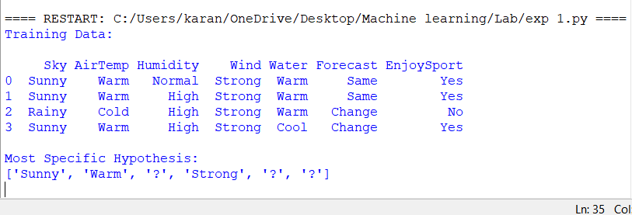
Result
Thus, the FIND-S algorithm was implemented successfully, and the most specific hypothesis consistent with the positive training examples was obtained as:

